
County Councillor Contact Details:
Email: cllr.jackie.charlton@powys.gov.uk
Tel: 07444495633

County Councillor Report - AGM May 2023 Llangattock
Report on the last 12 months in addition to the Monthly County Councillor Report
The last twelve months have been incredibly busy for me personally but also for Llangattock Community Council. This is a very hard working and effective council with great communication with the residents and so much to show for all their hard work. I feel I must congratulate the Community Council for the last year’s work and thank them for all they have done.
My work this year has been a bit of a split between taking on a new village in the extended Ward so getting to know Llangynidr and taking on a Cabinet role, which I had not anticipated and it has been a huge honour to take on both and link with the previous 5 years work in Llangattock.
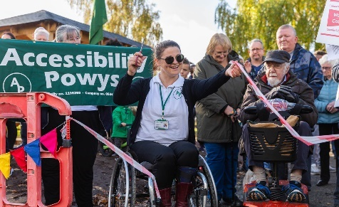
I also wanted to share the best photo of the year here too. This was one of the fantastic photos taken by Cllr Tim Jones who continues to keep your website up to date with great pictures, the Newsletter which goes out regularly and for grant applications and press releases. It was great to see the path in the Recreation Ground, the disabled toilet opened and linked to the great shelters in the park that so many have benefitted from . Well done Llangattock Community Council.
- Car Parking Charges – During the last 3 weeks I have received emails daily about the car parking charges in long stay car parks in Powys. By far the most correspondence has come from Crickhowell. Each email has been responded to personally and will be noted. In the autumn Powys will do a county wide review. This was planned earlier in the year but the work needed for the 20 mph changes across Wales took precedence. I will keep you updated here.
- Speed Watch Llangattock – We need to actively set this up over the summer months. Llangynidr have been undertaking Speed Watch every couple of weeks and reporting back to Go Safe. It would be good to get Go Safe up on the Mountain Road too. We can’t do Speed Watch there, but the Go Safe vehicle can monitor speeds on the road. Have contacted Go Safe.
- Bus Shelter – Getting there slowly. When writing this I was still awaiting a response from the officers in Transport to let me know how we proceed, what Powys will take on and what will be needed locally from the Community Council.
- Ash Trees will be surveyed over the summer and any work that needs to be carried out will be put into the work plan.
- Leaves on the road – I have been working with the Head of Highways to look at how we might seek funding for gully and leaf clearance. Sadly, we failed in the last round of Levelling Up Funding, but we are being told there will be a third round and we can apply. I have kept Cllr Ann Williams involved in how we might approach this on The Dardy.
- Light – All issues with streetlights has now been sorted.
- Road through village up to Church – I am still awaiting an update on this. Let’s hope we are not talking about this next year again!!
- Kept Kay Bailey Updated - With funding opportunities and council business.
- Llangattock Litter Pickers – Big Spring Clean event went really well. Lots of fly tipping sorted in partnership with Monmouthshire.
- County Councillor Surgery Llangattock – Next Surgery planned for June and will link with the Repair Café. May’s surgery will be in Llangynidr.

Powys Wide Issues:-
- Review of Winter Services – Consultation has now come to an end. This will inform the services to be delivered in the Winter this year and going forward.
- 20 MPH – The Highways Team are working extremely hard at getting all of the planning in place for rolling out 20 mph for 23 September.
- Section 6 Biodiversity Action Plan – The Cabinet approved this plan which outlines the work undertaken over the last 3 years. This links to the Nature Recovery Plan and is an important part of the authorities commitment to the Nature Emergency declared just over a year ago. I will send the document to Kay.
- Town & Community Council Conference – Please book your place for the Climate and Nature Emergency Conference on the 14th June.

