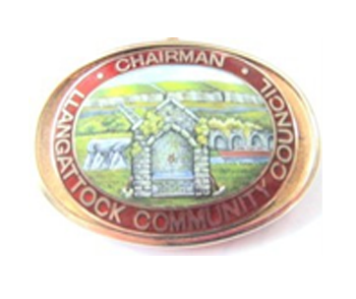
Llangattock Community Council Bench Dedication Policy

Benches are available to donate to the council to commemorate a loved one or allow members of the public to make a dedication of their choice. Donated memorial benches can be placed in Community council owned parks, and open spaces, within the ward.

New Policy
This policy supersedes all previous arrangements, policies and agreements and applies to all benches on Llangattock Council land.

Location
There is a wide range of locations across the Community. However, if you have a location in mind, please submit the application form and we will consider your request. Application forms can be obtained by contacting the clerk on 01873 598067 or from the website at: www.llangattock-cc.gov.wales

Options & Charge
The council offers two donated memorial bench options. One is to donate a new memorial bench, complete with a stainless-steel plaque with a dedication of your choice. The other option is to sponsor a re-furbished bench (subject to availability) with a new plaque attached complete with a dedication of your choice (prices on application).

Third Party Bench Provision Unfortunately we do not permit third parties to provide their own benches for installation on Llangattock Community Council land. There are several reasons for this;
- No guarantee of quality or longevity (LCC provides recycled plastic benches, made to last).
- We try to keep a uniform appearance to all benches around the Community. If people start supplying their own benches we will have different types of benches all over the Community.

New Bench & Plaque
A standard bench is 1.56m in length, made of recycled plastic material. The price includes a standard sized stainless-steel plaque, security fixed to the back rail of the bench.

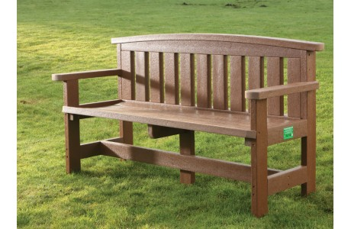

Standard Bench - Traditional 3-seater bench
Charges for New Bench & Plaque The charge for donated memorial bench with effect from 13th Dec 2017 is £1,262.80 and is inclusive of the provision of plaque (£45.00), bench (£412.80), installation (£750.00) and 10 years maintenance. The charge may alter from time to time as and when the council reviews its fees and charges. A £150 non-refundable deposit is required prior to your order being processed; this is to cover the cost of the plaque.

The fee covers the following: -
- Supplying a 1560mm bench.
- Stainless steel plaque and inscription. The standard stainless-steel plaque measures 63 x 152mm. Length of inscription 5 lines or under with no more than 36 characters in any line. Nonstandard plaques are available at an extra cost that would also be payable in advance of any order being placed.
- Base and installation (if a base is not required then the appropriate amount relating to this will be deducted from the cost)
- Contribution to ten years maintenance.
The council will invoice the applicant for the remainder of the fee after the seat has been installed.
Maintenance
New and re-furbished donated memorial benches will normally remain on site for a period of ten years, after which time they become available for rededication by the council. During the 10-year period the maintenance and reasonable repairs for the bench will be the responsibility of the council (the cost of which is included in the fee detailed above).
Vandalism and Damage
If the bench is damaged beyond repair the council will remove it. We will look to offer a replacement, but this will be at the standard charge applicable at the time. The council does not hold insurance cover for the damage, loss or destruction of benches. The council will not replace benches that are lost or damaged beyond repair. The donor of the seat will be notified if this is the case. Full maintenance costs will be refunded if the bench ceases to exist up to the three-year maintenance stage, or a 50% refund of maintenance costs if the bench ceases to exist at the six-year maintenance stage. After this period no refunds will be given.
Waiting Time
Applications for donated memorial benches are processed all year round, being approved on the third Tuesday of every month at the Council Meeting. Once an application has been approved it may take up to 12 weeks for the installation of a bench and plaque.
Conditions of Dedication
Donated memorial benches are installed for a fixed term of ten years. At the end of the ten-year period the council will attempt to contact the seat donor and offer to extend the period based on the charge of the service at that time of renewal. If after ten years a new period is not entered into the bench will be removed or refurbished and be made available for reallocation to a new donor.

The council will try and accommodate the applicant’s preference for the bench location. The council reserves the right to refuse an application if the preferred location is unsuitable and to offer an alternative site.

Once the seat has been installed it becomes the property of the council. The council then takes liability and responsibility for all maintenance requirements. No maintenance of any kind should be undertaken by the donor, their family or their representatives.

The Council’s parks, gardens and open spaces are there for the enjoyment of everyone and as such are not considered to be ‘memorial’ gardens. Therefore, floral tributes or any other memorabilia are not permitted to be left on or at seat locations. Any such items found will be removed by the council.

At the end of the dedication term, and where it is not possible to contact the seat donor to offer to extend the period or where the seat donor chooses not to renew the donation, the council may remove the memorial plaque and where reasonably practicable return it to the bench donor. The bench will then be refurbished and made available for reallocation to new donors.

It is the responsibility of the donor to notify the council if your address or contact details change.

